WDGS~WHAT DID GOD SAY! APRIL 2024

WDGS Monthly Newsletter
we're so glad you're here!
A Thanksgiving Update

The origins of Thanksgiving can be traced back to the 16th and 17th centuries, when the Wampanoag people and English colonists celebrated harvests and other events:
1578~``The first known Thanksgiving service in North America was held by Europeans in Newfoundland.
1621~The Wampanoag and Pilgrims celebrated a successful harvest with a three-day feast that included deer, corn, shellfish, and roasted meat.
1623~The Pilgrims held a religious Thanksgiving service in Plymouth, Massachusetts, it is recorded that they gave thanks to God, for providing them with rain after a long drought.
1789~The first Thanksgiving celebrated under the new Constitution was on Thursday, November 26, 1789. President George Washington issued a proclamation naming the first Federal Congress day response to a resolution passed.
1863~President Abraham Lincoln established Thanksgiving as a yearly celebration on the last Thursday of November.
1939~President Franklin D. Roosevelt moved Thanksgiving to
the second to last Thursday of November to encourage Christmas shopping during the Great Depression.
1941~President Roosevelt signed a bill making Thanksgiving the fourth Thursday of November.
From the Desk of, WDGS F O U N D E R & M A N A G E R

Hi my name is Alfreda, after I became unemployed in 2014, I elected to pursue my

divine passion and became a Licensed Ordained Minister. I seemed to find myself providing more Faith-Based coaching time to others via sharing Personal and Spiritual tools along with tips based upon my professional skills to apply resolution during conflicts. Through WDGS I became driven with desire and passion to create a social connection, marketing innovation, community development and people empowerment from my skills. WDGS was officially birthed and certified as an IRS Non-profit 501(c)3 Organization in 2017 and in 2020 WDGS became a United States Registered Trademark. I thank GOD for this 7th year of WDGS consistency assisting others.

Founder Featured Book is now available on AMAZON

TAP HERE https://a.co/d/7TAamn3 to ORDER

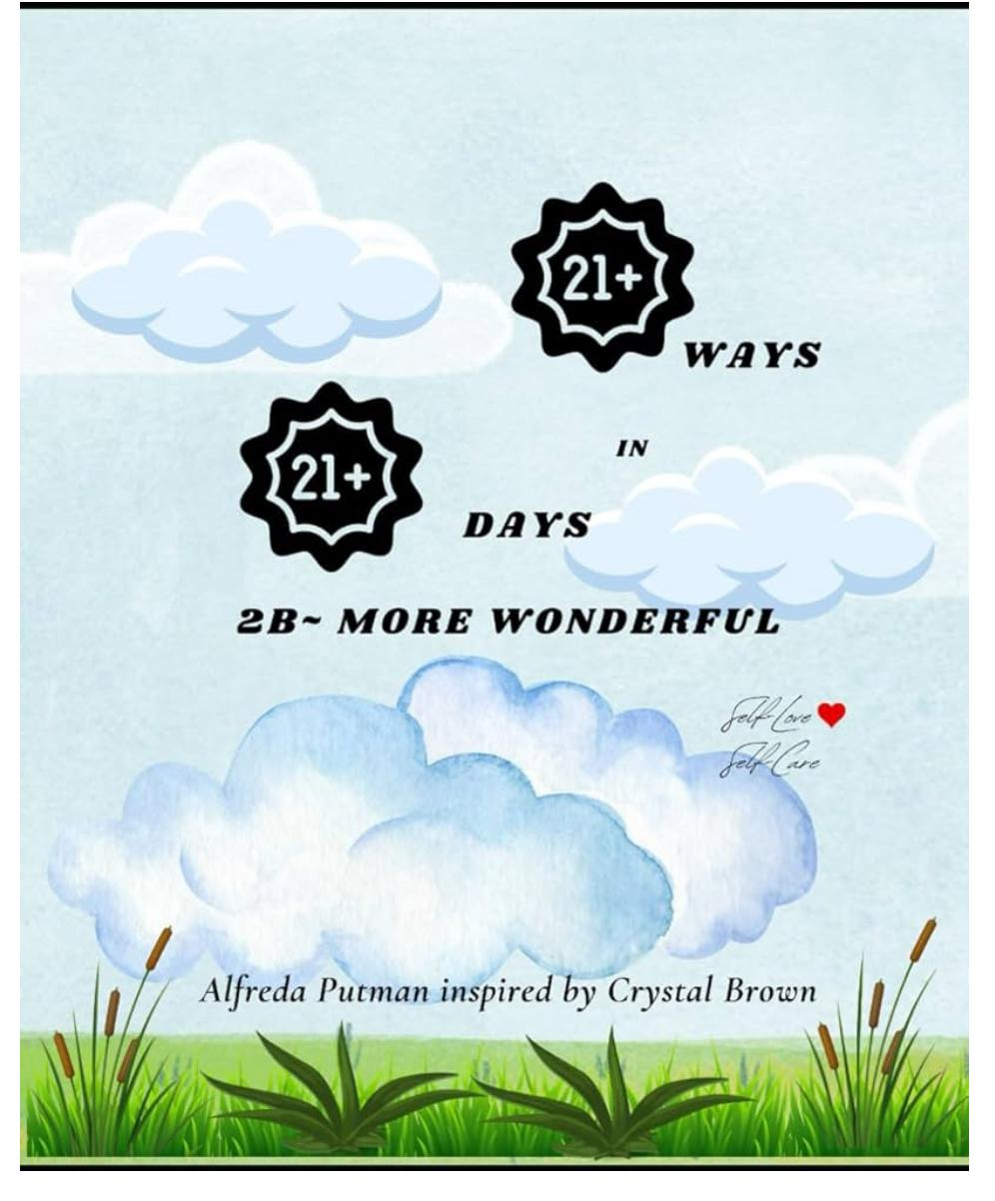



Our Latest Client New Project
WE ABSOLUTELY LOVED WORKING WITH THIS CLIENT!
Classy Kathy~

TAP HERE TO LEARN MORE OF THIS CLIENTS JOURNEY
https://a.co/d/9ZNca8y




Coming Up Events Free Resource
1 WORKSHOP LEARN HOW TO DO IT YOURSELF
40 Day Journey with JESUS How to publish your book for free

FIND OUT MORE INSTANT DOWNLOAD
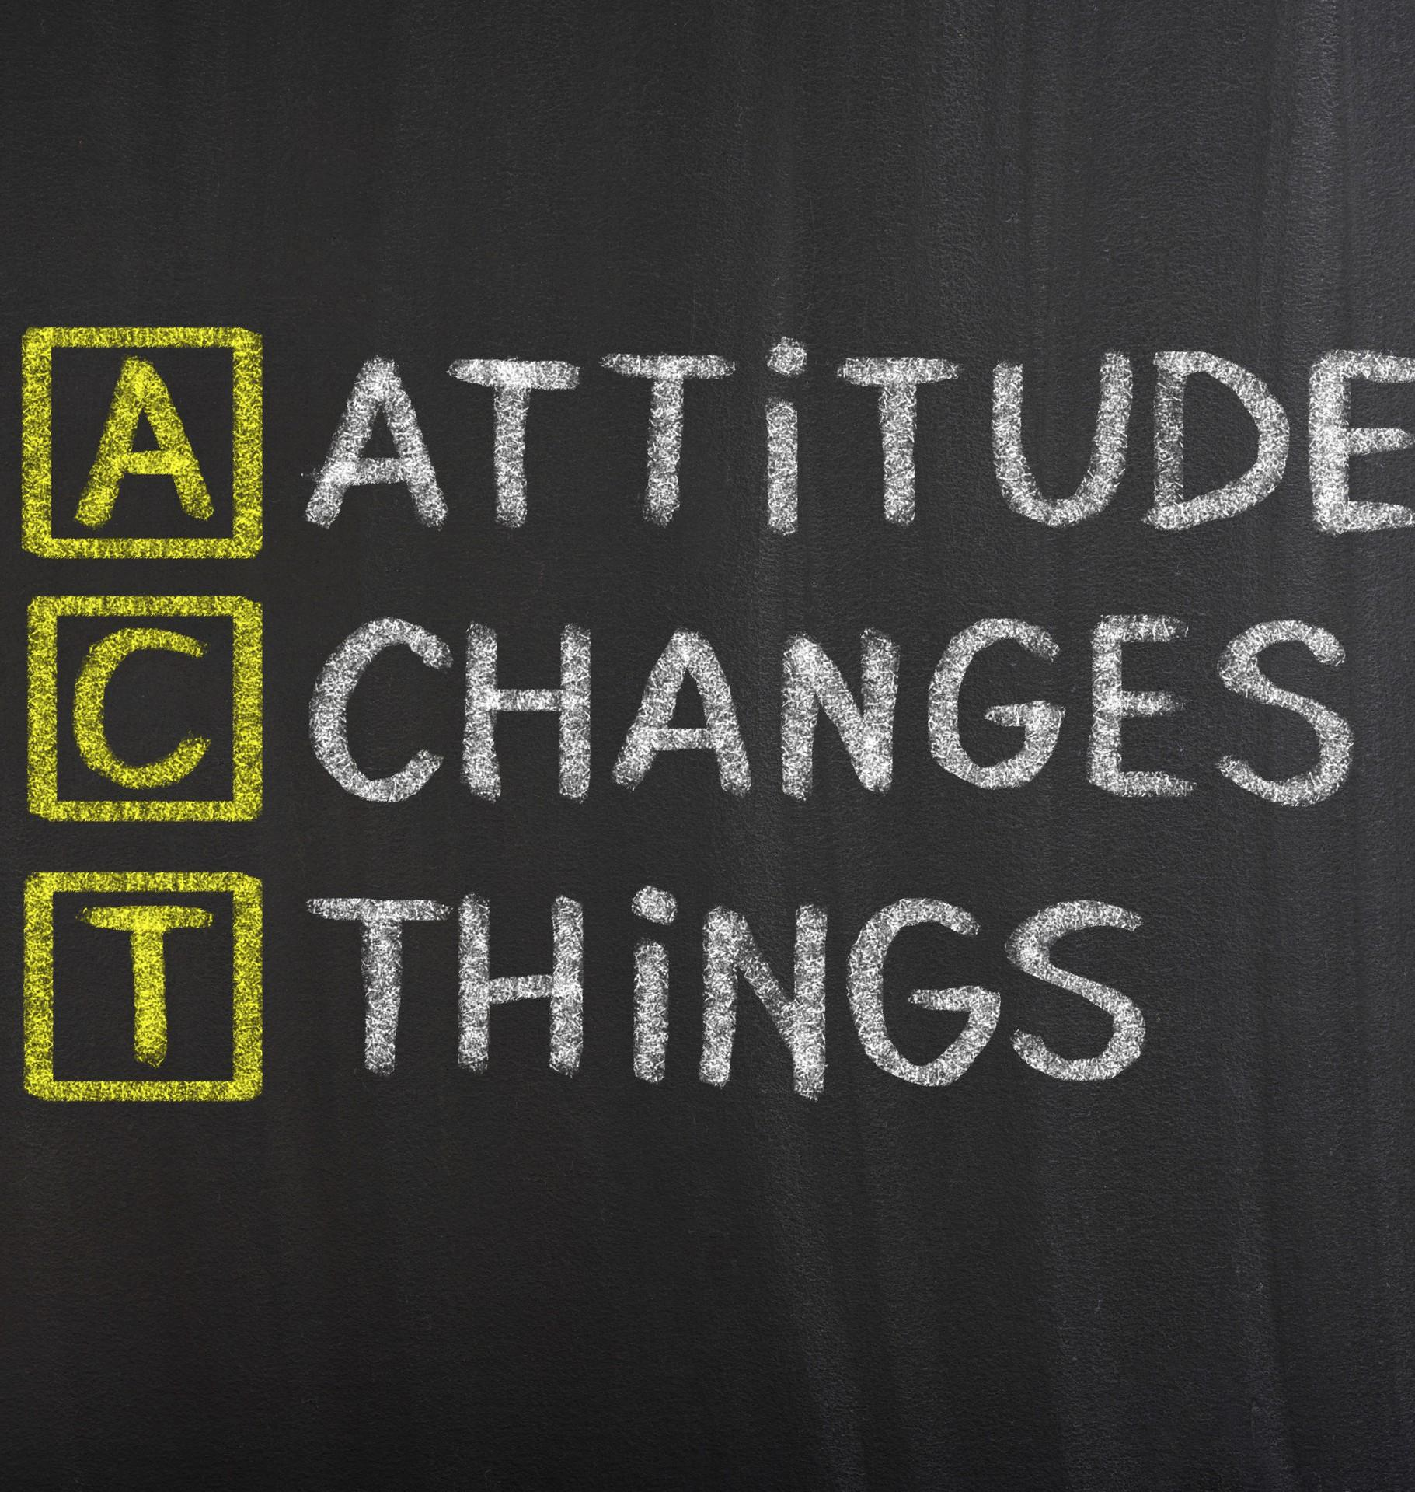

Pay Attention to ACT First
ATTITUDES
CONTRIBUTORY~ATTITUDES TERRIBLE~ATTITUDES
Info: Briefly explores three types of attitudes that can help or hinder:
#1. Always Negative
#2.Contributory Attitude and #3.Terrible Attitude.
Learn through the descriptions below how each Attitude hinders or helps our personal and
professional growth.

The Always Attitude
Characterized by praise or pessimism, clarity or
cynicism, and/or a tendency to focus on the bad or
good.
The Contributory Attitude
Marked by interest to assist, action, and a willingness to contribute to solutions.
The Terrible Attitude
Based on illogical beliefs, unfounded assumptions,
and disregard for evidence to treat you with respect.

Attitudes Always Matter
These 3 attitude types can hinder growth or provide
success. By recognizing and addressing them, each
individual can cultivate positive and productive
mindsets.
“One small positive thought in the morning can change your WHOLE day!” therefore, be meaningful who enters your circle in the morning in your house or calls over the phone.”

Work with us today
HAVE ANY QUESTIONS ABOUT WORKING WITH US?
You can get involved today by becoming a Volunteer Coach. Sign up and you will be joining a group of mind changers. We are striving to build a network strong enough to
impact positive change in the lives that will ALWAYS affect lives for the better.
LET'S CHAT

wdgs1000@gmail.com | wdgsguest@gmail.com

PLEASE VISIT OUR WEBSITE: WDGS.ORG

